Görkem Enes Bektaş
bektasgorkemenes@gmail.coım
Politechnika Czestochowa

Berke Can Kaya
bluten07@gmail.com
Politechnika Czestochowa

Signal analysis and Data processing

Laboratory Class - Experiment 4

Compulsory Tasks:

- Perform stationarity test of cross-covariance function for compound signals having the same period of deterministic components.

We compound a signal with a frequency of 12 and an amplitude of 6 with a standard deviation of 2 and give another signal from a channel with the same values. As a result, we have 2 compound signals with the same values. stationary test is performed for the cross correlation function formed by these signals. Since the standard deviation values we have chosen are low, the signal is clear in the first way, but as the signal lenght is increased, the signal becomes more pronounced.

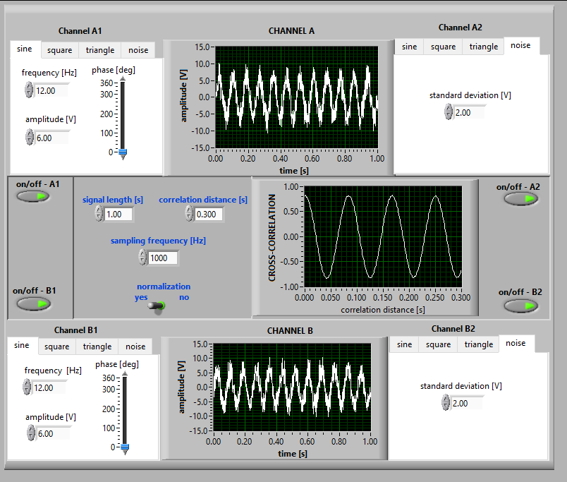
Figure 1 signal lenght [1]
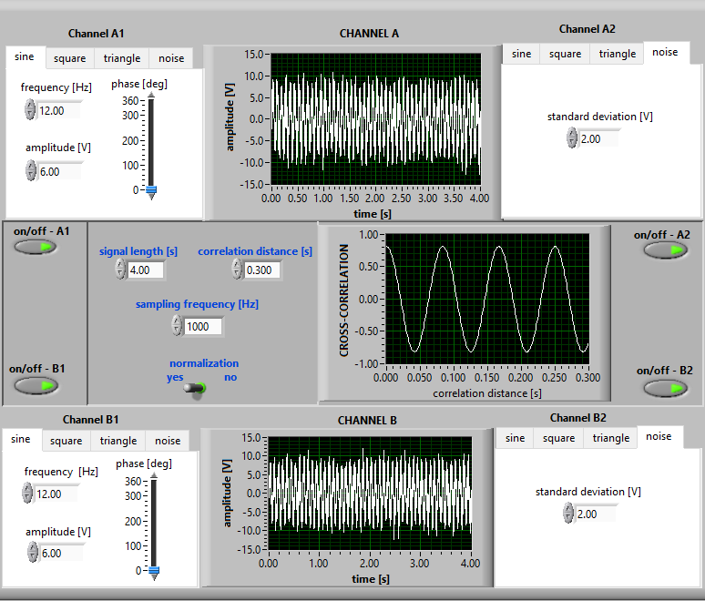
Figure 2 signal lenght [4]
- Analyse the relationships between amplitudes of correlated signals and correlation function for various deterministic signals of the same periods.
This time we have signals with the same frequencies but varying amplitudes and are not compounded. The peak value of the cross correlation function changes according to the variation of the amplitudes. The peak value depends not only on the amplitude but also on the type of signals, but the type of signals must be the same. As can be seen in the figures, the amplitudes are kept constant and only the type of signals is changed, but the peak value of the cross correlation function is changed, which means that there is a different rule for each type of signal.
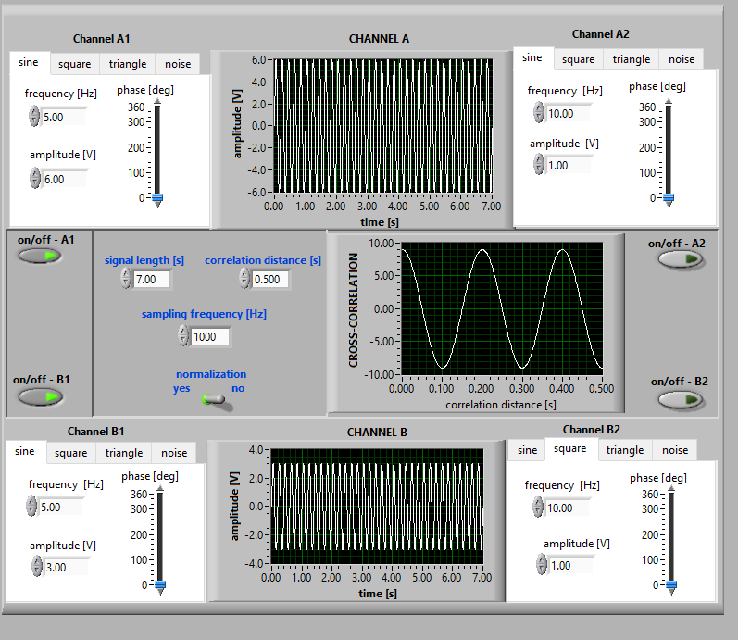
Figure 3
The peak value of the sine-sine signal correlation in Figure 3 is 18, which means that the rule for the sine signal is the amplitude of signal 1 times the amplitude of signal 2. $Amp1×Amp2$
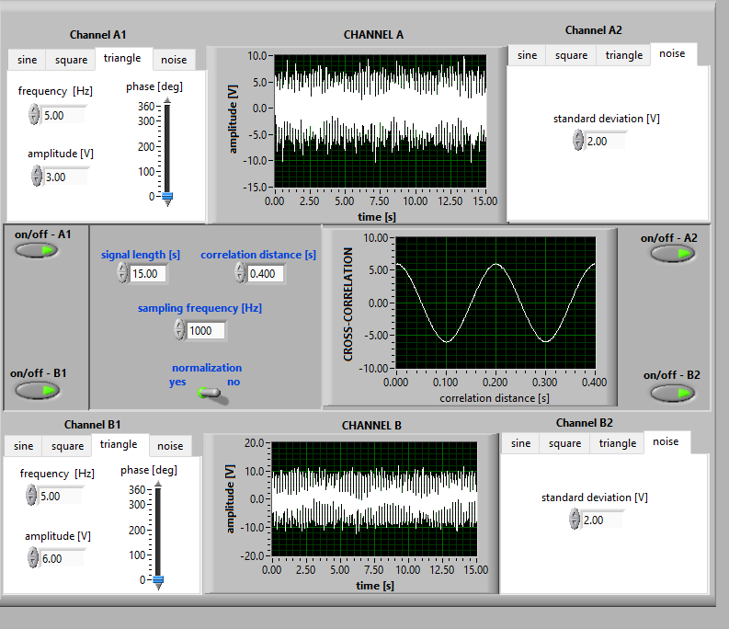
Figure 4
The peak value of the common triangle-triangle signals in Figure 4 is 6, which means that the rule of the sine signal is the amplitude of the 1st signal times the amplitude of the 2nd signal divided by 3. $\frac{Amplitude1 ×Amplitude2}{3}$
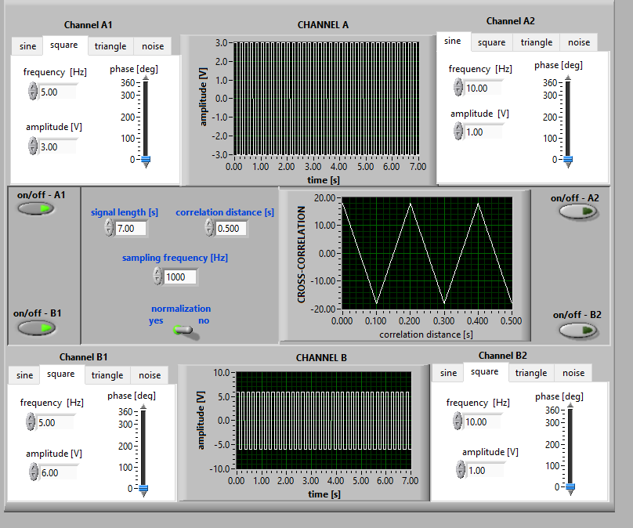
Figure 5
The peak value of the common triangle-triangle signals in Figure 5 is 9, which means that the rule of the sine signal is the amplitude of the 1st signal times the amplitude of the 2nd signal divided by 2.$\frac{Amplitude1*Amplitude2}{2}$
The increase in the peak value of the cross correlation function as the amplitude increases means that the signals are linear. Compounding the signals with noise shows that there is no change in the function. If the normalization value in the program is turned on, it is observed that the correlation function is always between 1 and -1.
- Analyse the influence of signals' phase angles on the correlation function distribution for deterministic signals of the same periods.
The phase part of the signal values allows us to change the phase angle of the signals. As we change the phase angles, the cross correlation function is observed to move and analyzed accordingly. For example, let the phase angle of signal A1 be 270 degrees and the phase angle of signal B1 be 180 degrees. With these changes, the peak of the cross correlation function appears at a correlation distance of 0.05.
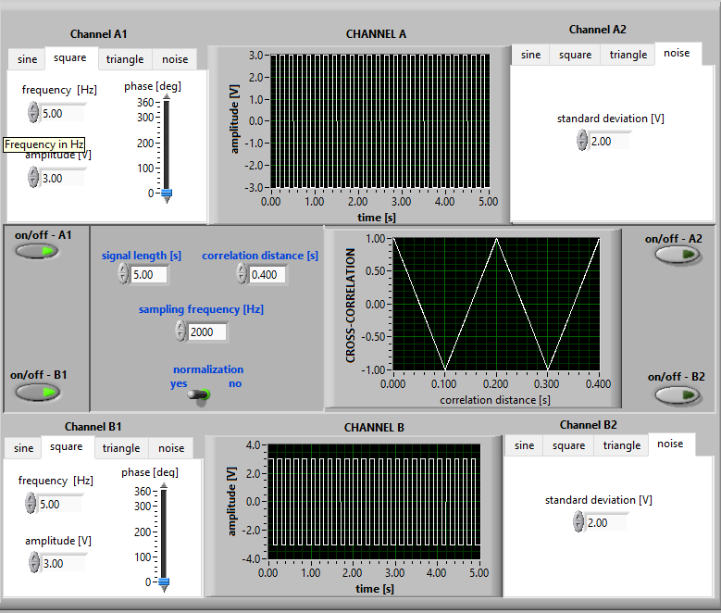
Figure 6

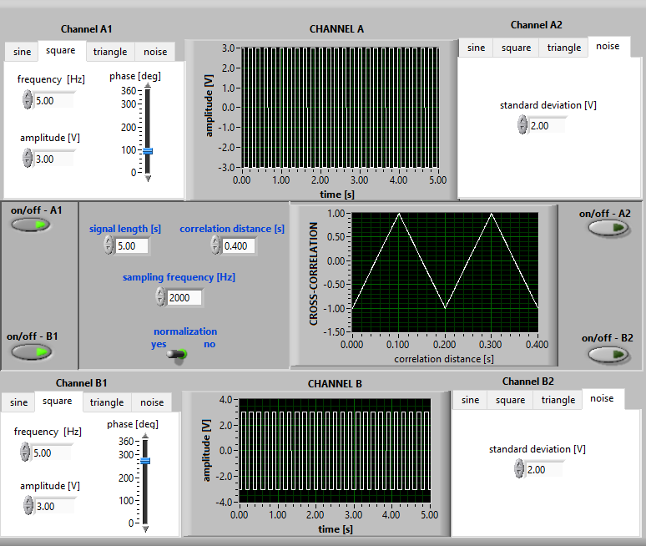
Figure 7
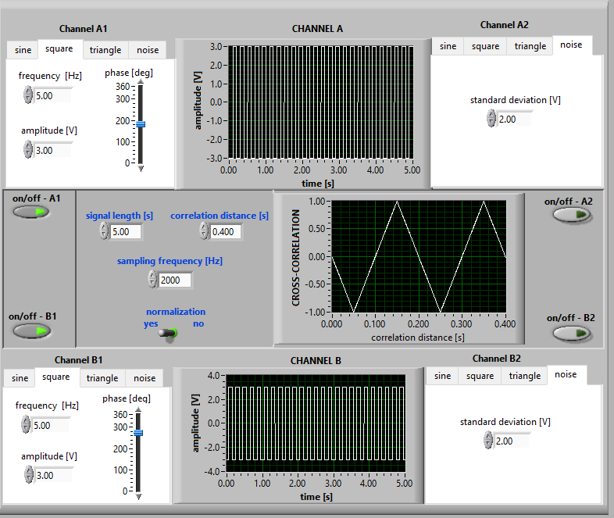
Figure 8

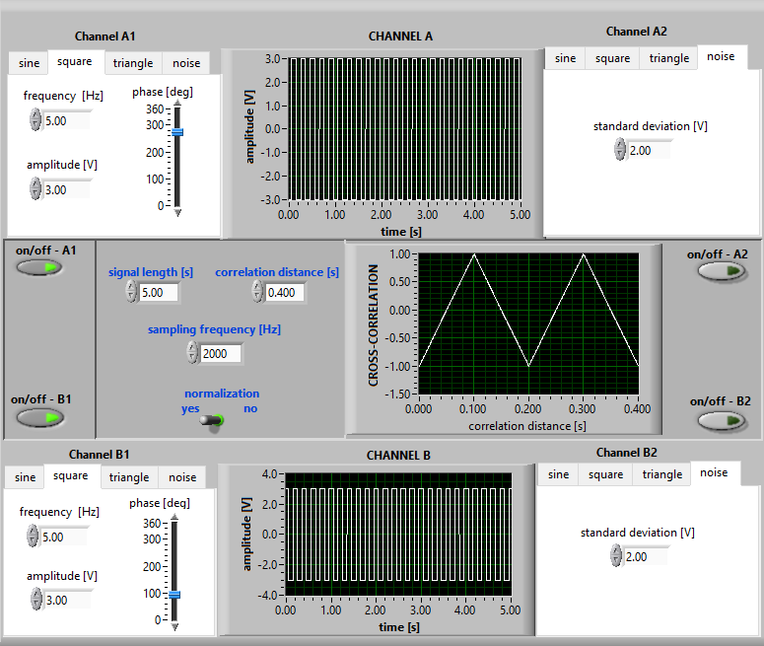
Figure 9

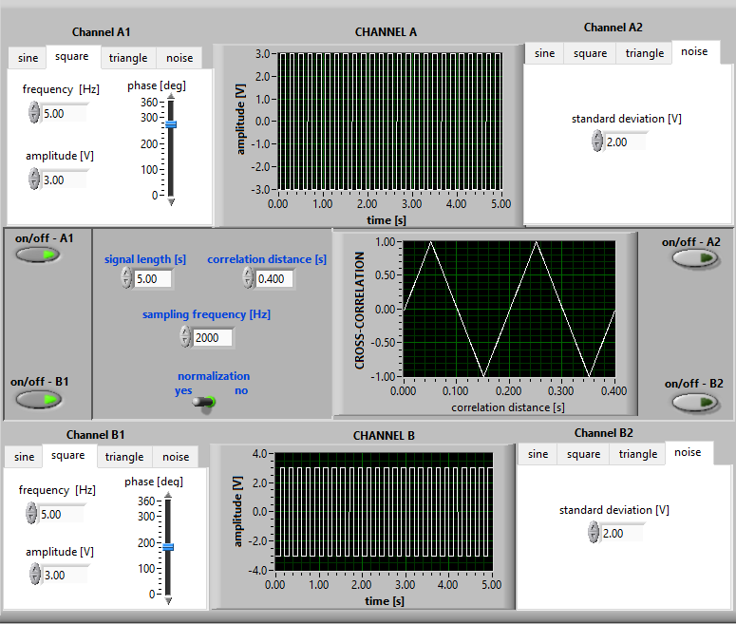
Figure 10
- Apply the cross-correlation function to the analysis of the "beat" phenomenon, i.e. combination of 2 sine waves of slightly different frequencies:
In this task, the amplitudes of the 2 signals are kept constant and their frequencies are changed. As shown in Figure 11, the frequency of signal A1 is 25, the frequency of signal B1 is 24 and the signal of the cross correlation function resembles a pair of glasses. In this signal 2 different periods are measured. First, the peaks in the first cycle of the signal, i.e. in the first lens of the glasses mentioned earlier, are counted and divided by 1. The number of these peaks is usually equal to whichever of the given signals has a lower frequency. In Figure 11, T1 = 1/24. The second is the sine wave in two cycles, i.e. in the 2 lenses of the glasses. This is usually the product of the correlation distance and the difference of the frequencies of the 2 signals divided by 1. For Figure 11, if the difference is calculated as 25-24=1 and correlation distance= 2, T2 = 1/2. 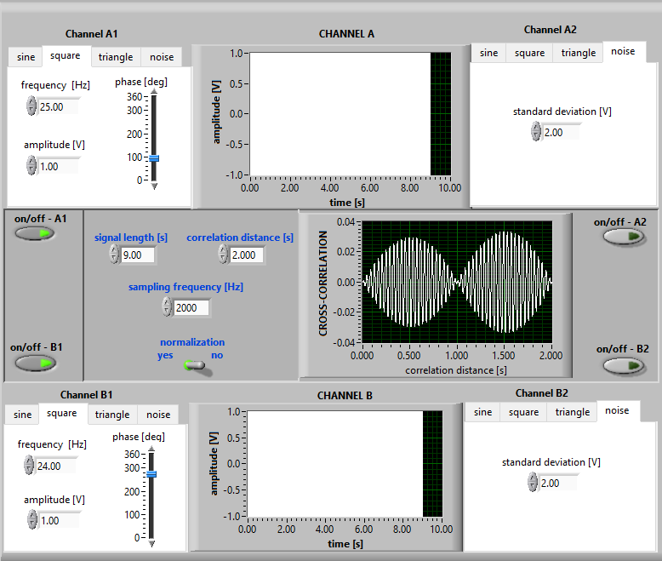
Figure 11
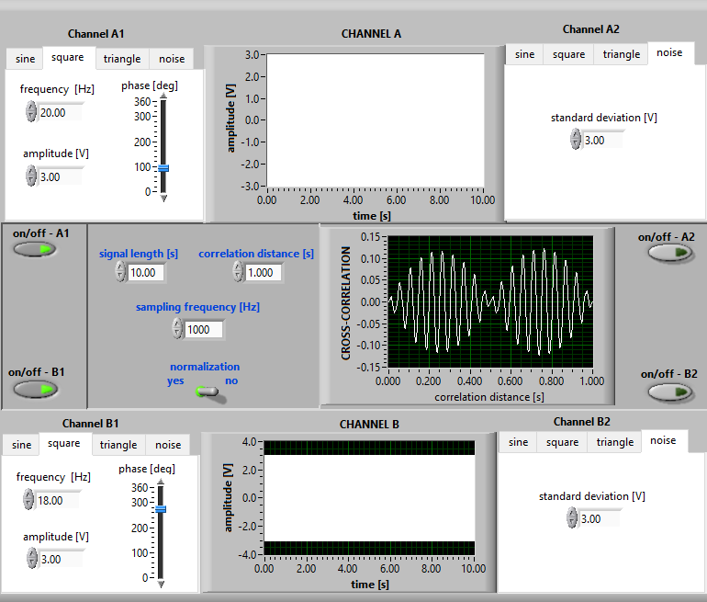
Figure 12
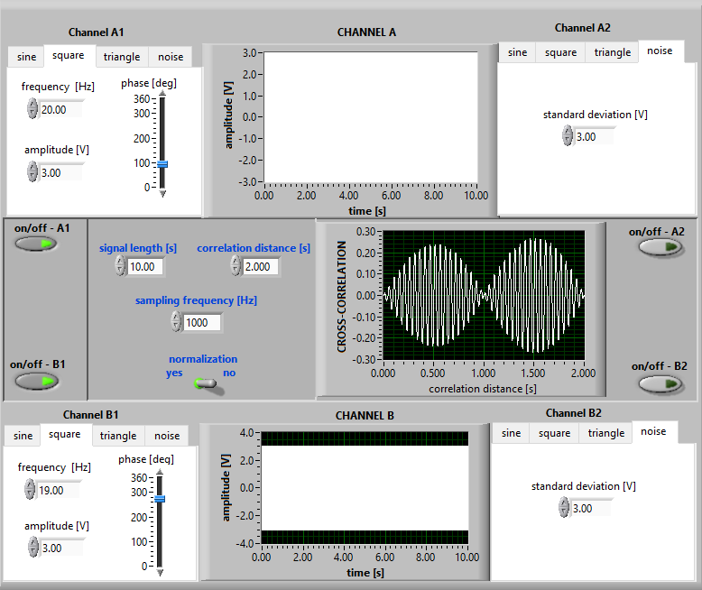
Figure 13
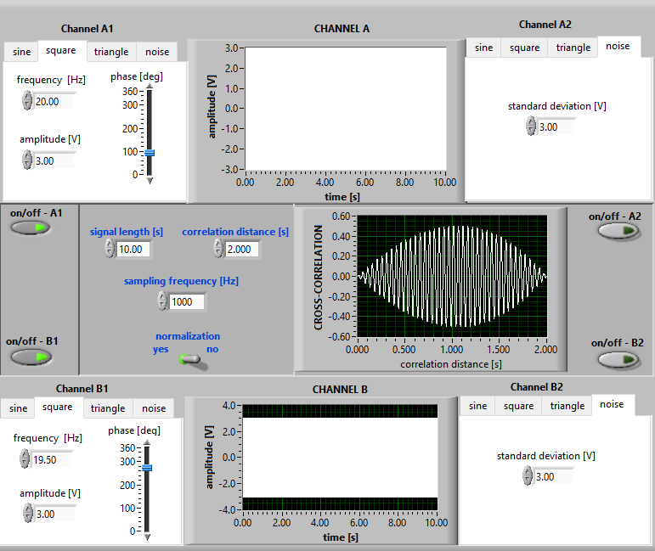
Figure 14

